P 9 Modifying Default Spanning Tree Behavior
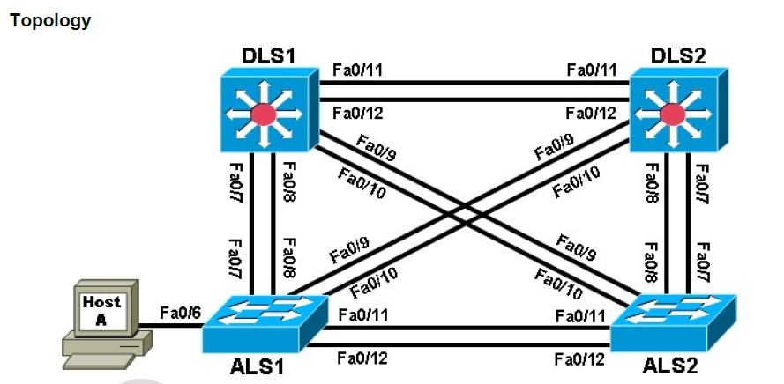

Background
Four switches have just been installed. The distribution layer switches are Catalyst 3560s, and the access
layer switches are Catalyst 2960s. There are redundant uplinks between the access layer and distribution
layer. Because of the possibility of bridging loops, spanning tree logically removes any redundant links.

Required Resources
• 2 switches (Cisco 2960 with the Cisco IOS Release 12.2(46)SE C2960-LANBASEK9-M image or
comparable)
• 2 switches (Cisco 3560 with the Cisco IOS Release 12.2(46)SE C3560-ADVIPSERVICESK9-M
image or comparable)
• 1 PC (optional) attached to switch ALS1.

Step 1: Prepare the switches for the lab.

DLS1(config)# interface range fastEthernet 0/7 - 12
DLS1(config-if-range)# switchport trunk encapsulation dot1q
DLS1(config-if-range)# switchport mode trunk

Step 2: Display default spanning tree information for all switches.

DLS1# show spanning-tree
DLS2# show spanning-tree
ALS1# show spanning-tree
ALS2# show spanning-tree

Switch# show spanning-tree
Switch# conf t
Switch(config)# interface range fastEthernet 0/1-24
Switch(config-if-range)# no shutdown
Switch(config-if-range)# end
Switch# show spanning-tree
DSL1# show interfaces trunk

Step 3: Configure specific switches to be primary and secondary root.

DLS2# debug spanning-tree events
Spanning Tree event debugging is on

DLS1(config)# spanning-tree vlan 1 root primary
ALS1(config)# spanning-tree vlan 1 root secondary
DLS1# show run | include span spanning-tree mode pvst
ALS1# show run | include span
DLS1# show spanning-tree

Step 4: Change the root port using the spanning-tree port-priority command.

DLS2# show spanning-tree
DLS1# show spanning-tree
DLS1(config)# int fastEthernet 0/12
DLS1(config-if)# spanning-tree port-priority 112
DLS2# show spanning-tree
DLS1# show spanning-tree

Step 5: Configure PortFast on an access port.
ALS1(config)# interface fastEthernet 0/6
ALS1(config-if)# shutdown
ALS1# debug spanning-tree events

ALS1(config)# interface fastEthernet 0/6
ALS1(config-if)# switchport mode access
ALS1(config-if)# no shut
ALS1(config-if)# end

ALS1(config)# interface fastEthernet 0/6
ALS1(config-if)# shutdown
ALS1(config)# interface fastEthernet 0/6
ALS1(config-if)# spanning-tree portfast
ALS1(config-if)# no shutdown
ALS1(config-if)# end
ALS1# undebug all

Step 6: Change root port using the spanning-tree cost command.

ALS2# show spanning-tree
ALS2(config)# interface fastEthernet 0/10
ALS2(config-if-range)# spanning-tree cost 10
ALS2# show spanning-tree

